FOR IMMEDIATE RELEASE
Uplift Center for Grieving Children to hold free public exhibition of artwork made by Philadelphia youth
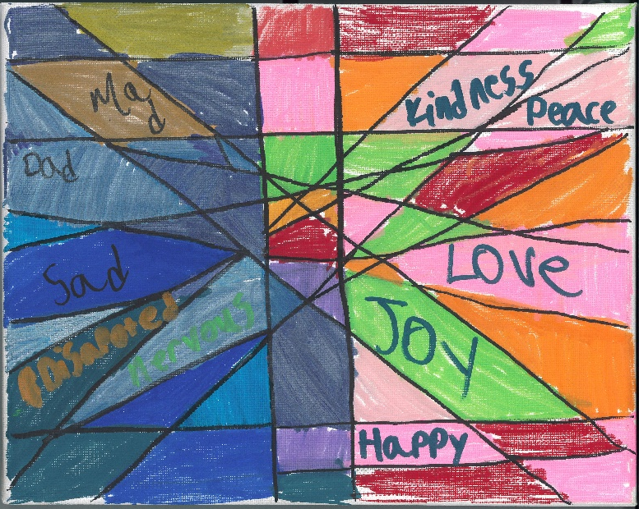
“Holding Grief: From Firsts to Always” showcases pieces by Uplift's grief services participants
PHILADELPHIA, August 31, 2026 – Philadelphia nonprofit Uplift Center for Grieving Children (Uplift), which provides free therapeutic grief support services and programs for youth and their families, announces Holding Grief: From Firsts to Always, a free exhibition of artwork created by local children, teens, and their caregivers through its “Uplifting Voices: Art That Speaks” community art program.
Holding Grief: From Firsts to Always recognizes that grief is not confined to singular moments but is an ongoing journey – from the first moment without someone to every moment after. Holding Grief will be held on Friday, November 6, 2026, from 5:00–7:30 p.m. at The Discovery Center (3401 Reservoir Dr, Philadelphia, PA 19121) in Strawberry Mansion. The free event will display works of art made during three free drop-in art nights which took place between June and August 2026. Attendees of all ages can enjoy creative activities, performances by the PME Drumline, and a catered buffet by Butter’s Soul Food. For more information, visit upliftphilly.org/art.
Uplift provides grief support services and programs each year to more than 1,000 youth in grades K–12 and their family members who are grieving the death of someone important, with a central message of grief as a natural response to loss. Groups typically meet in five- to six-week periods from September to May at Philadelphia schools, community meeting hubs, and on Zoom. A Master's level clinician supports each group and guides participants through age-appropriate activities and games alongside mindfulness and grief management skills education. Youth gain insight into their grief, which may look different from the way adults grieve, and connect with peers who share similar experiences.
Uplift's annual community art exhibition aligns with the start of Children’s Grief Awareness Month in November and Children’s Grief Awareness Day, which is observed on Thursday, November 19, 2026. According to the Childhood Bereavement Estimation Model, which draws from CDC data, 1 in 11 children in the United States will experience the death of a parent or sibling by age 18. The death of a family member or another important person is frequently one of the most disruptive childhood experiences and can adversely affect one’s lifelong health and well-being. Children’s Grief Awareness Month spotlights the impacts of grief on children and raises awareness of the importance of comprehensive grief care for youth and families.
###
About Uplift Center for Grieving Children
Uplift Center for Grieving Children (Uplift) was founded in 1995 by the Bereavement Program at St. Christopher’s Hospital for Children and incorporated as an independent nonprofit in 2000. Uplift’s mission is to help children grieving a death to heal and grow through their grief while strengthening families, communities and professionals’ understanding of how best to respond to their needs. Annually, Uplift directly supports more than 1,000 children in Philadelphia through no-cost therapeutic grief support services offered across the City. Its team also educates adult professionals and community members through training workshops on recognizing and responding to children’s bereavement and trauma. For more information, visit upliftphilly.org.
Key Personnel
 |  |  | 
Crystal M. Wortham, MSW, LCSW  Executive Director  crystal@upliftphilly.org | Teresa Méndez-Quigley, MSW  Associate Director of Family Services & Innovative Practices  teresa@upliftphilly.org | Katherine Streit, MSW, LCSW, M.S. Ed  Associate Director of School Services & Professional Trainings  katherine@upliftphilly.org | Samantha Anthony, M.Phil., MS, LPC  Senior Uplift Clinician  samantha@upliftphilly.org
Press Photos
Visit upliftphilly.org/art to download high-resolution photos of selected artworks and logos.

